Software Requirements Specification (SRS)

Event Management and Registration System (EMRS)

Project: Event Management and Registration System (EMRS)
Version: 1.0
Authors: <Student Name(s)>
Date: 03-09-2026
Status: Draft

Revision History
Version | Date | Author | Change Summary
1.0 | 03-09-2026 | <Name> | Initial draft

Approvals
Role | Name | Signature / Date
Project Manager | Aariz
Development Lead | Dhanraj Rathod
Product Owner | Vaishali Krishnan
QA/ Tester | Avinash Julakatti

Table of Contents
Event Management and Registration System (EMRS).................... 1
Revision History................................................................................. 1
Approvals........................................................................................... 1
Table of Contents................................................................................ 1
1. Introduction.................................................................................... 1
1.1 Purpose..................................................................................... 1
1.2 Scope........................................................................................ 1
1.3 Audience................................................................................... 1
1.4 Definitions................................................................................ 1
2. Overall Description......................................................................... 1
2.1 Product Perspective................................................................... 1
2.2 Major Product Functions........................................................... 1
2.3 User Roles and Characteristics.................................................. 1
2.4 Operating Environment............................................................. 1
2.5 Constraints................................................................................ 1
3. External Interface Requirements..................................................... 1
3.1 User Interfaces.......................................................................... 1
3.2 Hardware Interfaces.................................................................. 1
3.3 Software Interfaces.................................................................... 1
3.4 Communications....................................................................... 1
4. System Features (Detailed)............................................................. 1
5. Non-Functional Requirements (Detailed)........................................ 1
5.1 Security..................................................................................... 1
5.1.1 Security Objectives............................................................ 1
5.1.2 Security Requirements....................................................... 1
6. Quality Attributes & Acceptance Tests........................................... 1
7. System Models and Diagrams......................................................... 1
7.1 UML Use-Case Diagram........................................................... 1
8. Requirements Traceability Matrix (RTM)....................................... 1

1. Introduction

1.1 Purpose
This document is a Software Requirements Specification (SRS) for the Event Management and Registration System (EMRS). It defines the functional and non-functional requirements, interfaces, and verification criteria for a platform that lets organizers create and manage events and lets attendees discover, register for, and check in to those events.

1.2 Scope
Covers event creation and management, attendee discovery and registration (including waitlisting), payment for paid events, notifications, QR-based check-in, organizer reporting, and platform administration. Excludes venue physical infrastructure and any third-party payment gateway's internal implementation beyond its published API.

1.3 Audience
Developers, QA Engineers, Event Organizers, System Administrators, and Instructors/Evaluators.

1.4 Definitions
- EMRS – Event Management and Registration System
- UI – User Interface
- API – Application Programming Interface
- QR – Quick Response code
- JWT – JSON Web Token
- RBAC – Role-Based Access Control
- TLS – Transport Layer Security

2. Overall Description

2.1 Product Perspective
EMRS is a web application with a responsive user interface consisting of a front-end client, back-end API, relational database, and notification service for sending user notifications.

2.2 Major Product Functions
- Organizer account and event management
- Attendee event discovery, search, and registration
- Waitlist management and attendee notification
- Simulated payment processing for paid events
- Email notifications for registrations and event cancellations
- QR-coded e-tickets and event check-in
- Organizer analytics dashboard and reporting
- Platform administration and moderation

2.3 User Roles and Characteristics
• Attendee: browses and registers for events; expects a fast, mobile-friendly registration flow.
• Organizer: creates and manages events; needs a clear dashboard and reliable notifications.
• Admin: manages platform-wide users, categories, and policy enforcement.

2.4 Operating Environment
Modern web browsers on desktop and mobile devices over the internet; back-end hosted on a suitable server or cloud platform with a relational database.

2.5 Constraints
The system shall depend on internet connectivity and third-party email services where applicable. User personal data shall be handled securely, and sensitive payment card information shall not be stored.

3. External Interface Requirements

3.1 User Interfaces
Responsive web UI with distinct views for Attendee, Organizer, and Admin roles; accessible design (WCAG 2.1 AA), clear event search/filter UI, and a simple multi-step registration/checkout flow.

3.2 Hardware Interfaces
Optional: camera-equipped device (phone/tablet) used by Organizer staff to scan attendee QR e-tickets at check-in.

3.3 Software Interfaces
• Email service/API for registration and cancellation notifications.
• Maps/Geocoding API (optional) for venue location display.

3.4 Communications
The system shall use HTTPS/TLS to secure communication between the client and server.

4. System Features (Detailed)
Each functional requirement below has a unique ID (EMRS-F-###), a description, and an implied acceptance criterion (successful completion of the described behavior) traceable to a test case in the Test Plan / RTM.
ID | Feature | Description | Priority
EMRS-F-001 | User Registration | System shall allow a new user to create an account by providing their name, email, password, and role (Attendee or Organizer), with email verification. Admin accounts will be assigned separately. | High
EMRS-F-002 | User Login / Authentication | The system shall authenticate registered users using their email and password. Upon successful login, the system shall issue a JWT (json web token) session token, which will be used to authenticate the user's subsequent requests. | High
EMRS-F-003 | Password Reset | System shall allow users to reset their password through a secure password reset process. | Medium
EMRS-F-004 | User Profile Management | System shall allow users to view and update their profile details, including name and contact information. | Medium
EMRS-F-005 | Create Event | System shall allow an Organizer to create an event with title, description, category, date/time, venue (physical/virtual), capacity, ticket details and prices | High
EMRS-F-006 | Edit / Update Event | The system shall allow Organizers to edit event details before the event starts and maintain an audit log of all changes. | High
EMRS-F-007 | Cancel Event | System shall allow an Organizer to cancel an event. Cancellation will automatically be notified to all registered attendees. | High
EMRS-F-008 | Browse / Search Events | System shall allow users to search and filter events by keyword, category, date range, and location. | High
EMRS-F-009 | View Event Details | System shall display event details including the agenda, speakers, venue, and venue map. | Medium
EMRS-F-010 | Register for Event (RSVP) | System shall allow an Attendee to register for an event, validating capacity and preventing duplicate registration. | High
EMRS-F-011 | Cancel Registration | System shall allow Attendees to cancel their registration before the event starts and free the reserved slot. | Medium
EMRS-F-012 | Waitlist Management | System shall place Attendees on a waitlist when an event is full and notify the next eligible Attendee when a slot becomes available. | Medium
EMRS-F-013 | Payment Processing | System shall provide a simulated payment process for paid events and record the transaction status as successful, failed, or pending. | High
EMRS-F-014 | Notifications & Reminders | System shall send registration confirmation and event cancellation notifications to registered attendees via email. | High
EMRS-F-015 | e-Ticket / QR Code Generation | System shall generate a unique QR-code for each e-ticket on confirmed registration. | Medium
EMRS-F-016 | Event Check-in | System shall allow an Organizer to scan/validate a QR ticket at the venue and mark attendance in real time. | High
EMRS-F-017 | Organizer Dashboard & Reports | System shall provide organizers a dashboard showing registration counts, revenue, and attendance analytics, exportable as CSV. | Medium
EMRS-F-018 | Admin User & Event Moderation | System shall allow Admins to suspend users for violating platform rules, remove policy-violating events, and manage event categories. | Medium
EMRS-F-019 | Post-Event Feedback | System shall allow attendees to submit a rating and feedback form after an event concludes. | Low

5. Non-Functional Requirements (Detailed)
NFRs below are measurable and tied to the Test Plan. IDs follow EMRS-NF-###.
ID | Category | Requirement
EMRS-NF-001 | Performance | 95% of page requests shall complete within 2 seconds under normal system load.
EMRS-NF-002 | Availability | The system shall remain available during scheduled demonstration and testing periods, excluding planned maintenance.
EMRS-NF-003 | Scalability | The system shall support increased numbers of users and registrations during peak event periods without significant performance degradation.
EMRS-NF-004 | Usability & Accessibility | The web interface shall be responsive and usable across mobile, tablet, and desktop devices.
EMRS-NF-005 | Maintainability | The codebase shall use a modular structure and include automated testing for core system functions.

5.1 Security

5.1.1 Security Objectives
• Protect the confidentiality and integrity of user personal data and payment transaction records.
• Ensure only authenticated, authorized organizers and admins can create, modify, or delete events and user accounts.
• Prevent unauthorized or automated (bot-driven) abuse of the registration process.

5.1.2 Security Requirements
ID | Requirement
EMRS-SEC-001 | All user passwords shall be stored using a salted hash (bcrypt or Argon2); plaintext passwords shall never be logged or stored.
EMRS-SEC-002 | All client-server communication shall be encrypted using TLS 1.2 or higher.
EMRS-SEC-003 | The system shall enforce role-based access control (RBAC) for Attendee, Organizer, and Admin roles on every protected endpoint.
EMRS-SEC-004 | Login and registration endpoints shall implement rate limiting and CAPTCHA to mitigate brute-force and bot-driven fraudulent registrations.
EMRS-SEC-005 | Payment card data shall never be stored on application servers; all payment handling shall be delegated to a PCI-DSS compliant payment gateway (tokenized transactions only).

6. Quality Attributes & Acceptance Tests
Exit criteria for acceptance: All high-priority functional requirements shall be implemented and verified, with no critical security or NFR failures. The RTM shall show that all associated test cases have passed.
Acceptance test suites: Authentication, Event Management, Registration & Waitlisting, Simulated Payment, QR Check-in, Notifications, Performance, Security, and Usability.

7. System Models and Diagrams

7.1 UML Use-Case Diagram

Figure 7.1 — Attendee use cases: account registration, event discovery, registration/waitlisting, payment, e-ticketing, an post-event feedback.??

Figure 7.2 — Organizer and Admin use cases: event lifecycle management, dashboard/reporting, attendee check-in, and platform moderation.??
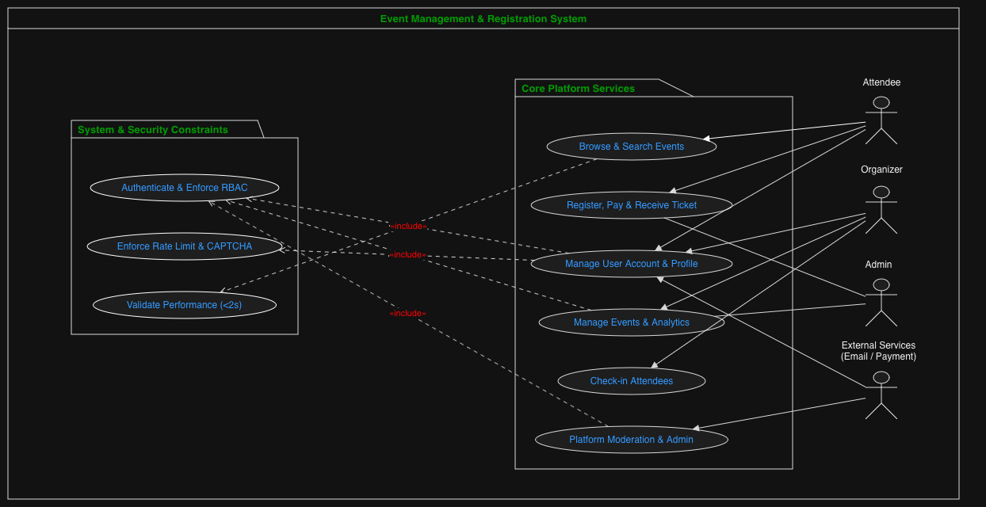

8. Requirements Traceability Matrix (RTM)
The Requirements Traceability Matrix (RTM) links each requirement in the SRS to the test cases used to verify it. The table below shows the current mapping. The remaining requirements and test cases will be added as the Test Plan is finalized.

Req ID | Requirement short | Section ref / Design Spec | Module | Test case(s) | Status (N/P/A) | Comments
EMRS-F-001 | User Registration | 4.1 / DS-Auth-01 | AuthModule | TC-Auth-01, TC-Auth-02 | N | Covers valid registration and invalid/duplicate registration
EMRS-F-002 | User Login and Authentication | 4.1 / DS-Auth-02 | AuthModule | TC-Auth-03, TC-Auth-04 | N | Covers successful and failed login
EMRS-F-003 | Password Reset | 4.1 / DS-Auth-03 | AuthModule | TC-Auth-05 | N | Verify password reset process
EMRS-F-005 | Create Event | 4.2 / DS-Event-01 | EventModule | TC-Event-01, TC-Event-02 | N | Covers valid event creation and input validation
EMRS-F-006 | Update Event | 4.2 / DS-Event-02 | EventModule | TC-Event-03 | N | Organizer can update event details before event starts
EMRS-F-007 | Cancel Event | 4.2 / DS-Event-03 | EventModule | TC-Event-04 | N | Verify event cancellation and attendee notification

